**PENSERV Enrollment plan**

Step 1:

Step 2:

Step 3:

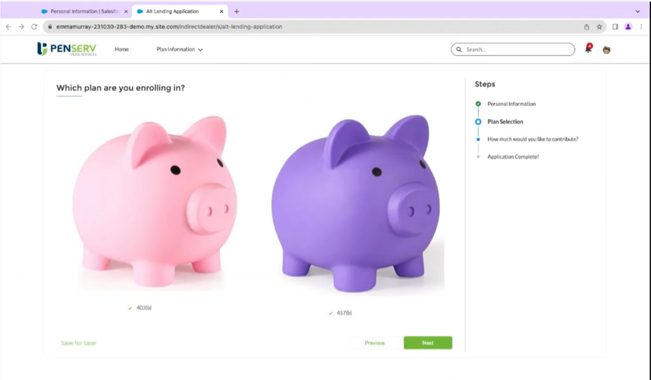

Step 4:

If they select two plans both should be displayed.

Step 5: if we select only one plan then it should display on one plan.

Step 6: if contribution amount is more than 5000 error throws. Contribution percentage if they do then contribution amount disappears vice versa.

Step 7: Signature window

Step 8: completed window.

